Test Case: tc001_SPX_Dev5_Crear_Requisicion_Spot_Tipo_Cobro_CC
Step 1 - Enter username and password and click to button Enter : Credentials Entered
Image file-name: QC_Testing-tc001_SPX_Dev5_Crear_Requisicion_Spot_Tipo_Cobro_CC-1788297059618

Step 2 - Select to UEN and Access to Spot Buy Requisitions : UEN Correctly selected and Correct access
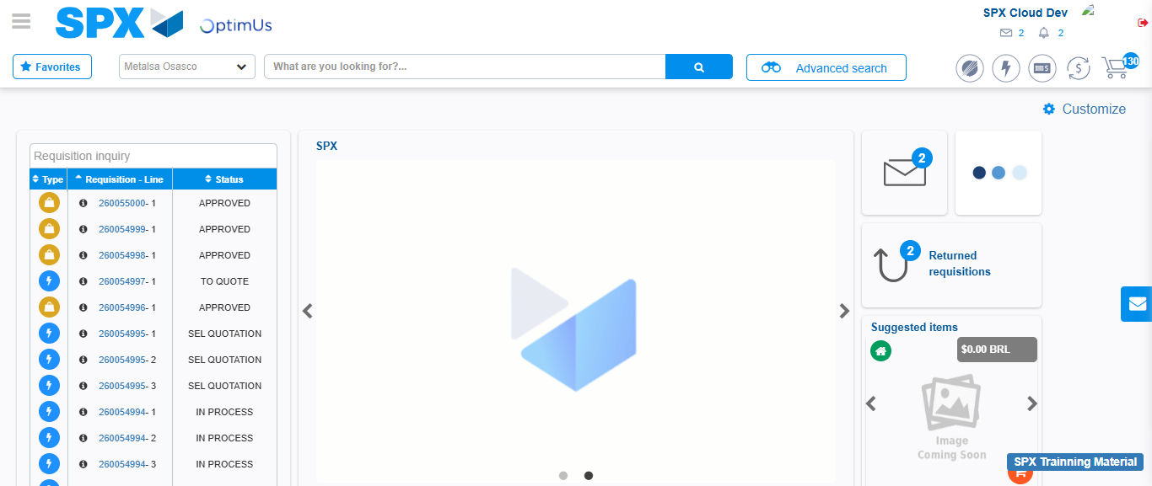Image file-name: QC_Testing-tc001_SPX_Dev5_Crear_Requisicion_Spot_Tipo_Cobro_CC-1788297084896

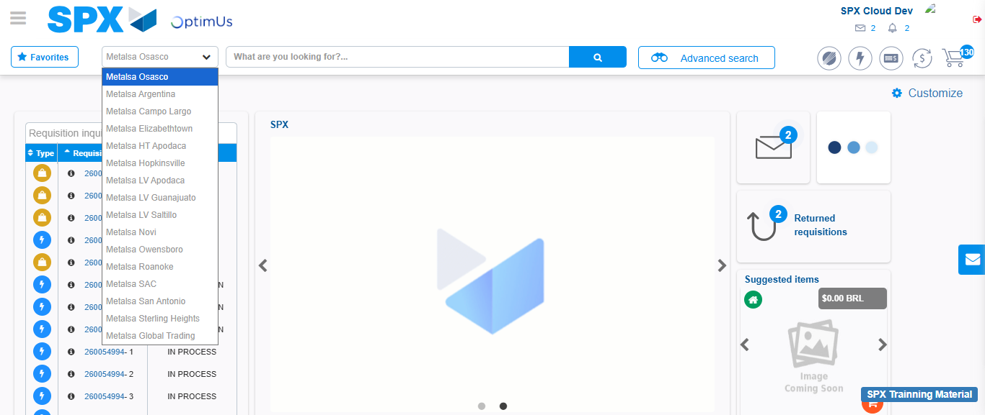Image file-name: QC_Testing-tc001_SPX_Dev5_Crear_Requisicion_Spot_Tipo_Cobro_CC-1788297085442

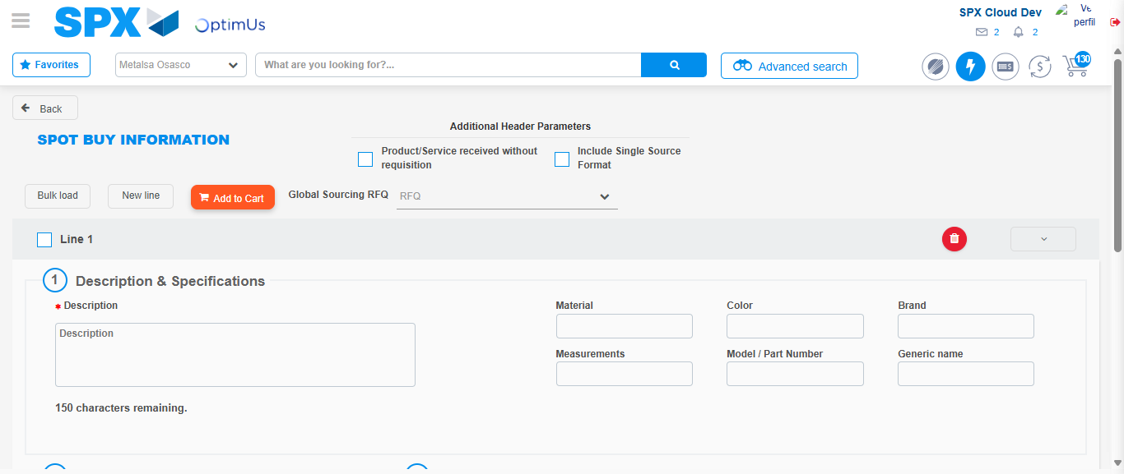Image file-name: QC_Testing-tc001_SPX_Dev5_Crear_Requisicion_Spot_Tipo_Cobro_CC-1788297107631

Step 3 - Data Capture Spot Buy Requisition : Data captured correctly
Image file-name: QC_Testing-tc001_SPX_Dev5_Crear_Requisicion_Spot_Tipo_Cobro_CC-1788297107846

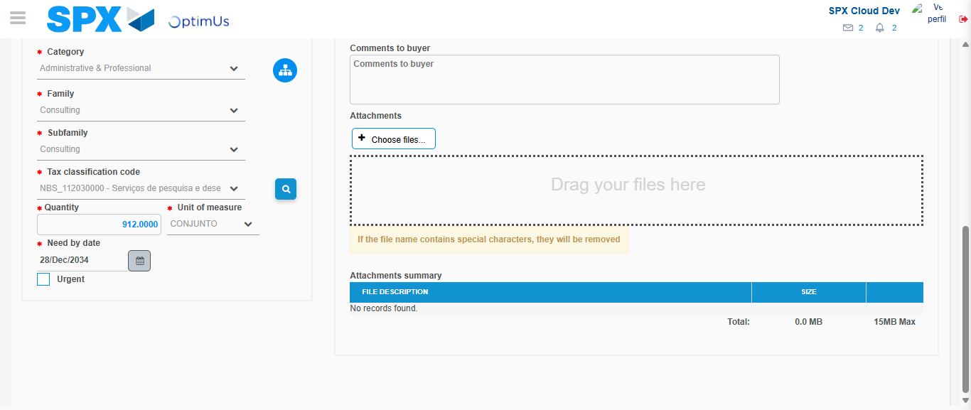Image file-name: QC_Testing-tc001_SPX_Dev5_Crear_Requisicion_Spot_Tipo_Cobro_CC-1788297121580

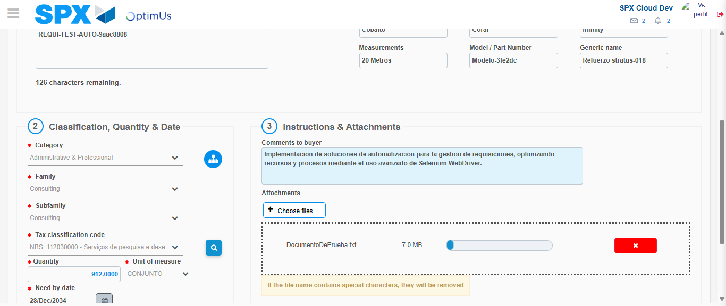Image file-name: QC_Testing-tc001_SPX_Dev5_Crear_Requisicion_Spot_Tipo_Cobro_CC-1788297122321

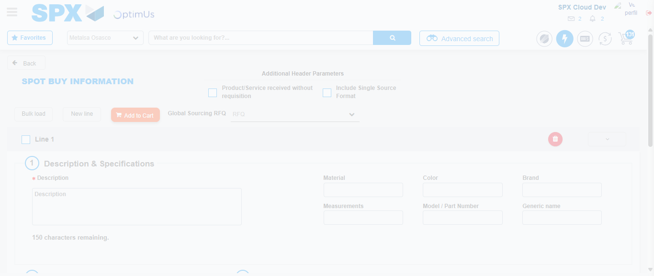Image file-name: QC_Testing-tc001_SPX_Dev5_Crear_Requisicion_Spot_Tipo_Cobro_CC-1788297127302

Step 7 - Return to Main Page SPX : Return to Main Page SPX
Image file-name: QC_Testing-tc001_SPX_Dev5_Crear_Requisicion_Spot_Tipo_Cobro_CC-1788297084896

Image file-name: QC_Testing-tc001_SPX_Dev5_Crear_Requisicion_Spot_Tipo_Cobro_CC-1788297085442

Image file-name: QC_Testing-tc001_SPX_Dev5_Crear_Requisicion_Spot_Tipo_Cobro_CC-1788297107631

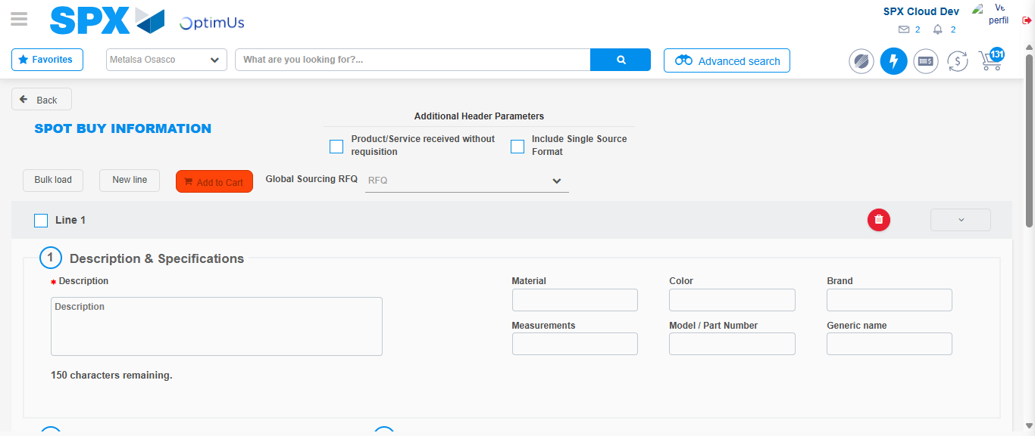Image file-name: QC_Testing-tc001_SPX_Dev5_Crear_Requisicion_Spot_Tipo_Cobro_CC-1788297129524

Image file-name: QC_Testing-tc001_SPX_Dev5_Crear_Requisicion_Spot_Tipo_Cobro_CC-1788297129688

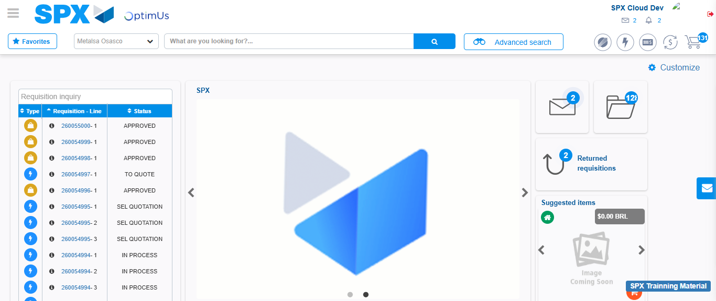Image file-name: QC_Testing-tc001_SPX_Dev5_Crear_Requisicion_Spot_Tipo_Cobro_CC-1788297150748

Step 8 - Log Out : Log Out SPX
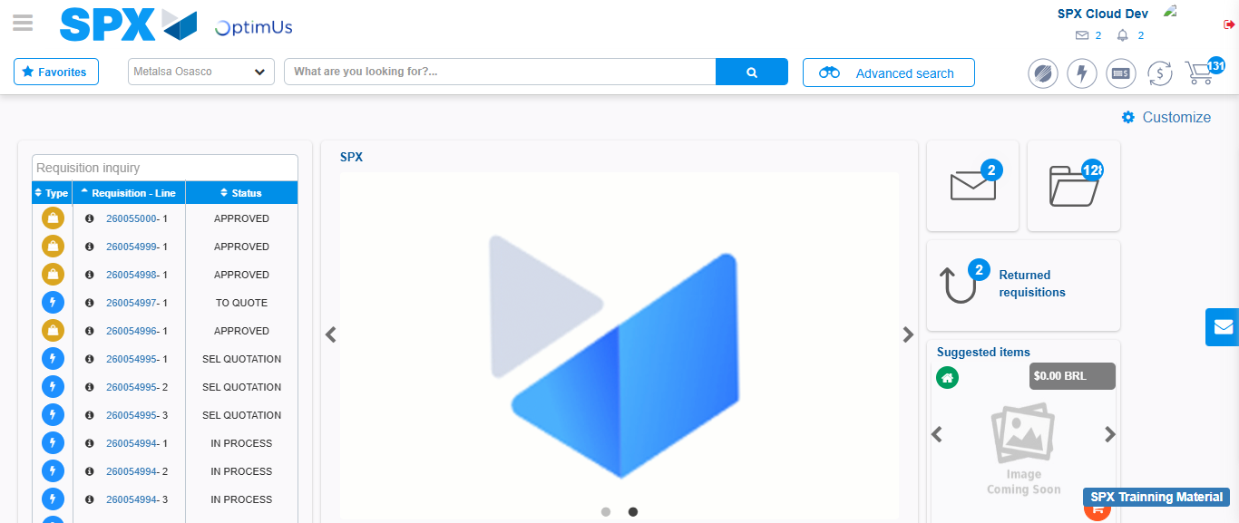Image file-name: QC_Testing-tc001_SPX_Dev5_Crear_Requisicion_Spot_Tipo_Cobro_CC-1788297151013

